Enterprise Web Application Development

Project Documentation

EWD621S | January 31, 2021

**Author**

|  |  |  |
| --- | --- | --- |
| Name | Qualification Registered for: | Student No: |
| Lossert A Shatumbu | 07BAIF B.Informatics | 212031228 |
| Mutengua D.T Kandjii | 07BAIF B.Informatics | 219155143 |
| Jeanne Sreauss | 07BAIF B.Informatics | 216098157 |

**Distribution List**

|  |  |
| --- | --- |
| Name | Title |
| Mr. Mbeyava | **Lecturer** |
|  |  |
|  |  |

Table of Contents

**INTRODUCTION** 3

Document Scope and Purpose 3

Target Audience 4

Acronyms/Abbreviations 4

System Environment 4

Design approach 4

Data flow design 4

GUI Design 4

System Design Considerations 5

Web-site directories 5

Exception handling 5

Modules/Tabs and their functions 5

Admission tab 5

Area of study 5

Apply to study 5

Admission status 5

Learners Tab 5

Registration 6

Study Track 6

Examination Results 6

Announcements 6

Staff tab 6

Schedule a Test 6

Update Student Marks 6

Student Marks 6

Contact us 6

# **INTRODUCTION**

This introduction provides an overview of the System Architecture Document for C Heuva JSS web application system. In includes the purpose, scope, target audience, design approach, main component design and high level system design considerations of the system.

## Document Scope and Purpose

This document provides a description of the technical design for C Heuva JJS Web Application system-Portal. This document’s primary focus is to describe the system know how, technical, databases used for how the business requirements will be realized. The document will provide an architectural overview of the system to depict different aspects of the system. This document also acts as a guidance for the system developers.

C Heuva JSS website will be targeted to the school mostly as this website will be able to have learners to apply at this respective school to be educated. This website will also have the function where learners can register what field they want to study e.g., commerce and continuing through the year the learners will also be able to view their progress during their time of study. Teachers will have administrator roles where they can create profiles for these learners as well be able to insert progress results and update them. The website also includes a contact us page where the learners are able to get in Contact with the school.

## Target Audience

This document is targeted (but not limited) to technical stakeholders

* Development Team
* IT Management
* Support Staff

It is assumed that the reader has a technical background in Enterprise Web Application and Development.

## Acronyms/Abbreviations

|  |  |
| --- | --- |
| Acronym | Meaning |
| GUI | Graphical User Interface |
|  |  |
|  |  |
|  |  |
|  |  |

## System Environment

* Development: Notepad++
* Diagrams: Bizagi Modeler, Lucid Chart
* Database: MySQL
* Server: Wamp
* Discussions: MS Teams and WhatsApp group

## Design approach

The design approach used here is based on the following:

## Data flow design

The data flow design is internet-based. We will be using MySQL database to retrieve and store data to utilize data displayed by the web portal user interface.

## GUI Design

Wire Frames are used for UI design. Wire frames are an effective tool for collecting and presenting functionality, navigation, and content of an application or web site. Annotations or notes attached to elements or widgets on the wire frame help to communicate specific functions.

Home Tab

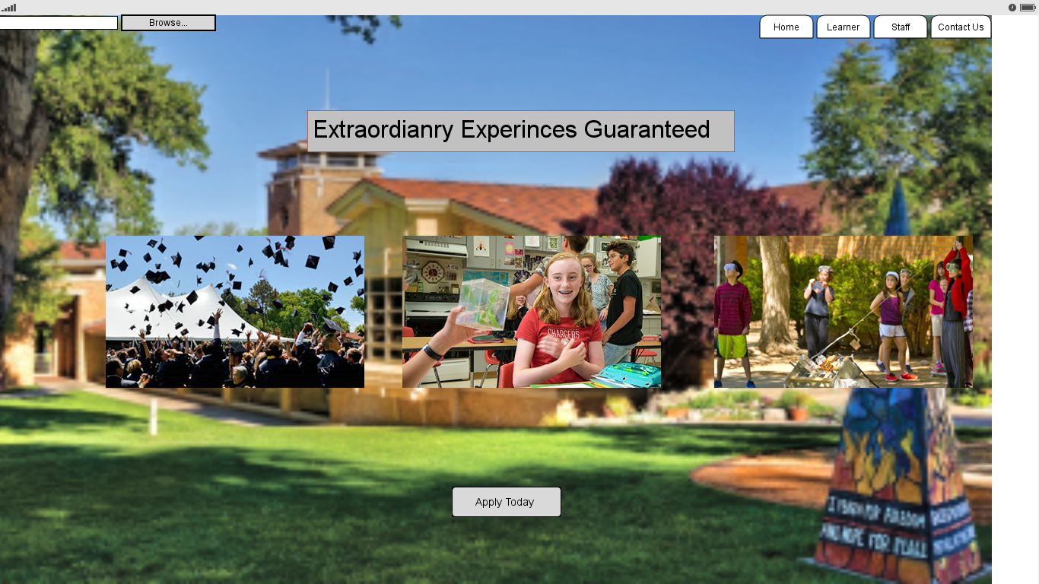

Admission Tab

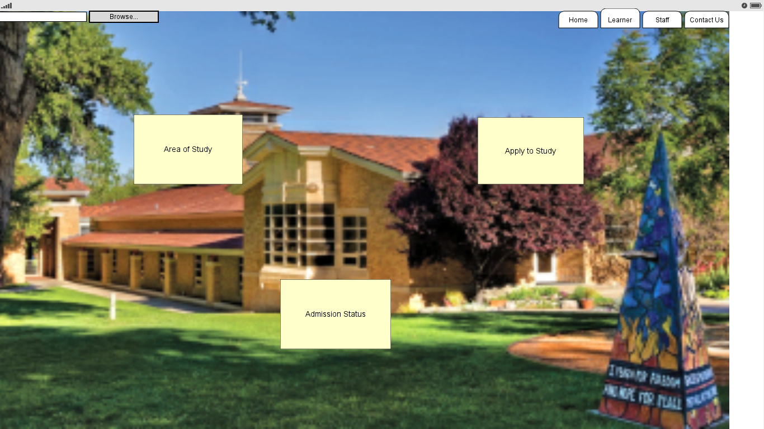

Learners Tab

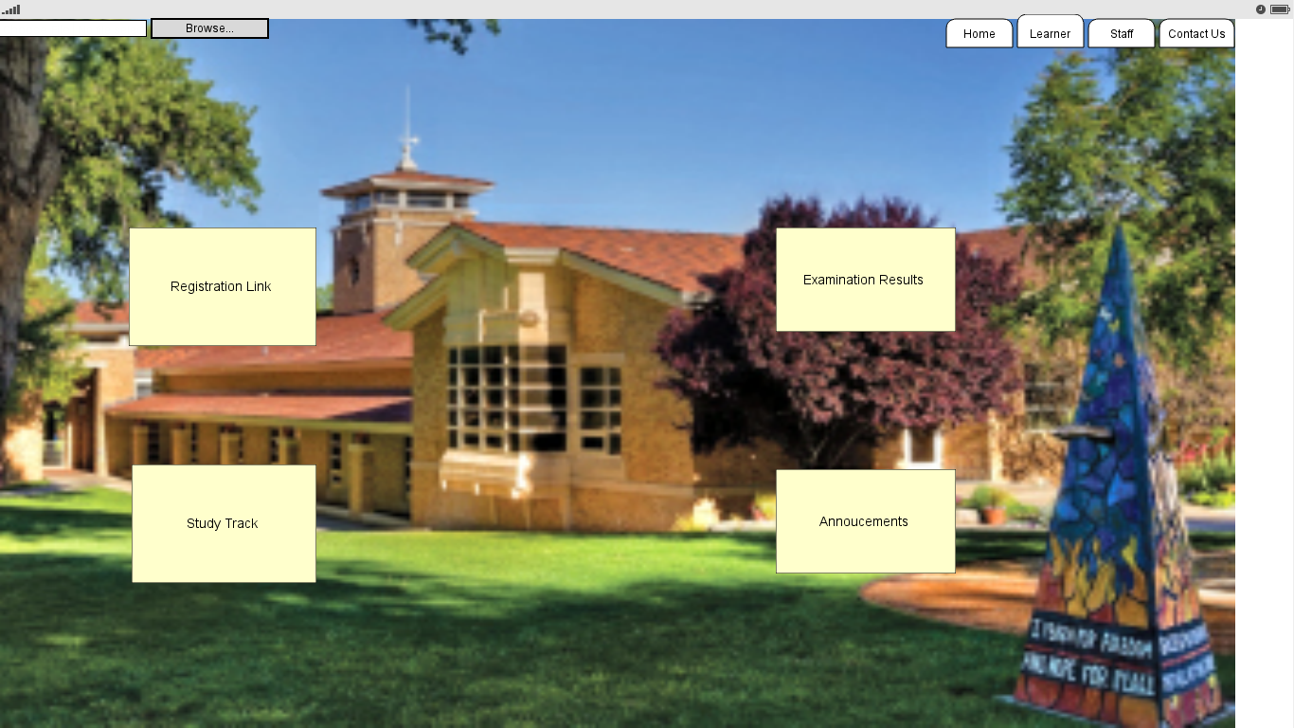

Staff

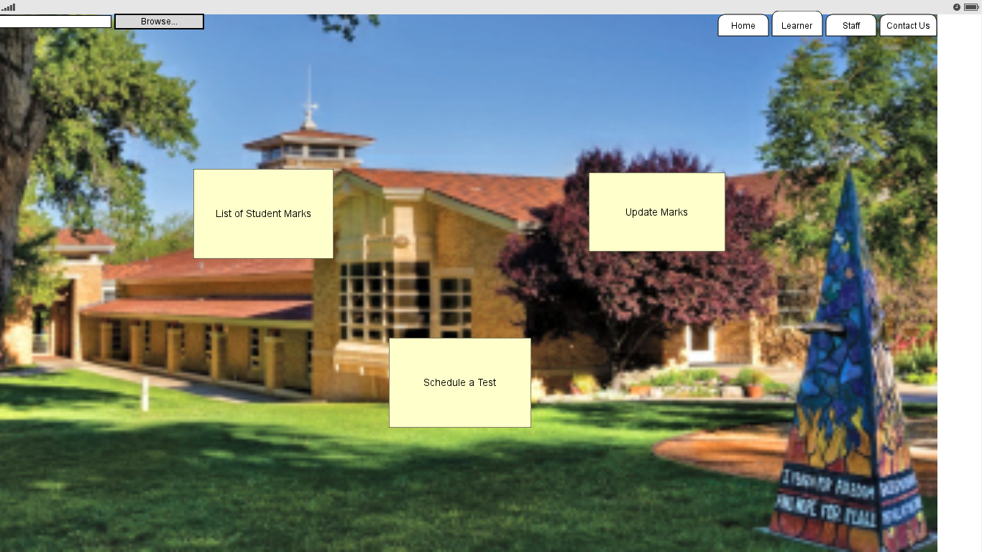

Contact Us

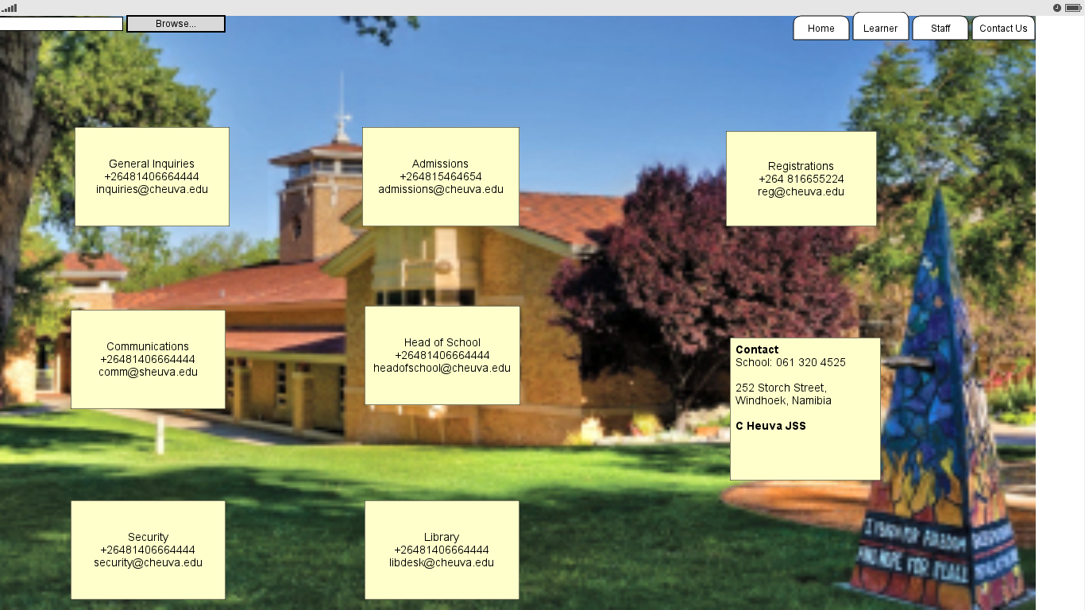

# System Design Considerations

## Web-site directories

The below directories will be used to organize the C Heuva JSS pages used in the web-page

User site Directories

* Root Directory – all web pages related to user functions
* Images Directory – Contains the images used by the system.

## Exception handling

A good way to track the system health and performance is to build in exceptions. In this system we will put in tryLogin exception if the passwords do not match, and handling that exception in the login method.

# Modules/Tabs and their functions

## Admission tab

Under this tab we have the following links.

### Area of study

The user or learner to be is presented with list of fields available at the school. The user will then have a choice to search through all field of studies. Once the user found the suitable area of study he/she will have a choice to click on apply to study.

### Apply to study

The user is presented with a login form requesting username and password. If new he/she will be asked to register. They then enter their credentials and the systems logs them in and show them the application form which consists of name, surname, age, gender etc.

### Admission status

The user is presented with a login form requesting username and password. They enter their username and password. The system then logs them in and shows them how far his/her admission status is and if complete, has the learner been accepted or rejected.

## Learners Tab

Under this tab we have the following links.

### Registration

While logged in, the user selects “Registration” from the learners tab. The system will bring up a registration form in which the learner will need to fill in all mandatory fields, the learner will then be prompt to confirm. Once confirmed, the system will give out a confirmation message.

### Study Track

While logged in, the learner will have an option to view his/her progress report.

### Examination Results

While logged in, at the end of each semester the student will be able to view their results after taking the exams.

### Announcements

An announcement link will be integrated. When the learner clicks on this link, it will show all upcoming events. The learner will be able to click on it and see more details about the announcement.

## Staff tab

Under this tab we have the following links.

### Schedule a Test

The teacher is presented with a login form requesting username and password. Once logged in, the teacher is now able to schedule to setup up a test online.

### Update Student Marks

While logged in, the user will get a dropdown list of the subject to update, the system then displays a list of learners. User then select the learner that he/she wish to update and clicks on save then close. The system updates the learner’s info to the supplied info.

### Student Marks

While logged in, the system displays a list of subject available to the staff for viewing and download. When the teacher clicks on one, a display tab pops up and if requested the download manager.

## Contact us

This tab consist of all the information about the school contact details, work address and other relevant information.

# Entity Diagram

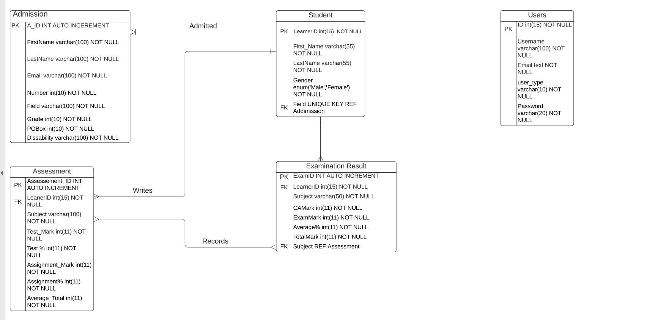

# Use Case Diagram

Use case diagrams serve two purposes: As a form of graphical table of contents listing the individual use-cases and also to define the boundary of what is included as part of the proposed system and what is not included. In this scenario, we are only going to show the student case diagram.

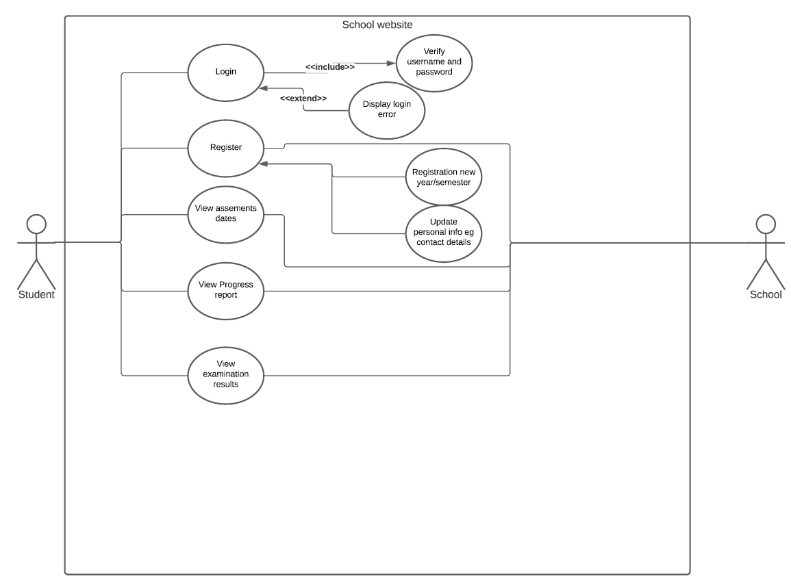

# Use Case Description

|  |  |
| --- | --- |
| Use Case ID: | EWD |
| Use case name: | Learners login and register |
| Description: | This use case allows the student to login into the system and register and access the relevant function according to the student role. To login the learners should enter their username and password. |
| Primary actor: | Learners |
| Secondary actor: | School website |
| Preconditions: | 1. Learners must login successfully |
| Include use cases: | 1. System validate and verify username and password |
| Extend Use Cases: | 1. System displays login error message. |
| Post-conditions: | Learners can register and access other functions associated with the learner’s role. |
| Main Flow: | 1. Learners Logins 2. The system verifies and validate login credentials. 3. (Extension point: If password or username are incorrect display a login error) 4. Upon successful login student can register if it is a new semester or update their personal info 5. The student request to view assessments date. 6. The system displays list of assessments date. 7. The student request to view progress report. 8. The system displays list of progress report. 9. The student request to view examination results. 10. The system displays a list of examination results. |
| Alternate Flows: | 1a. Assessments dates   1. Learners logins   5 The learners request to view assessments date.   1. The system displays list of assessments date.   1b. Progress report   1. Learners Logins 2. The learners request to view progress report. 3. The system displays list of progress report.   1c. Examination Results   1. Learners Logins 2. The learners request to view examination results.   10 The system displays a list of examination results. |

# Sequence Diagram

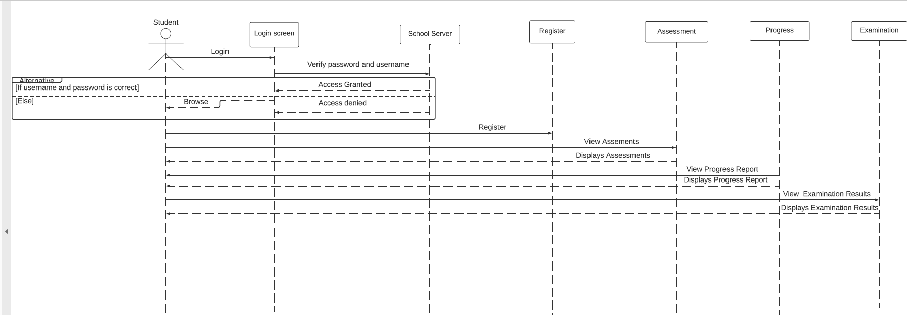

# Conclusion

In this document, we described the templates as guidance and knowhow of the system developed. This entails a system development that is less time consuming and resource demanding in this unprecedented times.